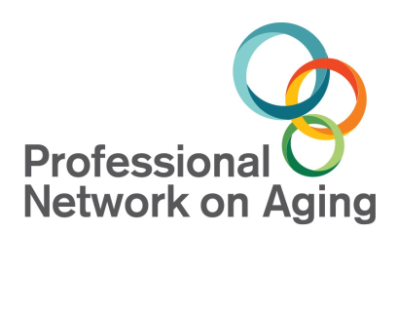
SENIOR ADVOCACY AWARD
In Memory of Bob Bernstein
NOMINATION PACKET

INTRODUCTION

The Professional Network on Aging established the Senior Advocacy Award in 2009,
in memory of Bob Bernstein, to recognize an individual whose life and work demonstrates a passion for service to seniors and whose actions are a
strong advocacy for the senior community.

WHO WAS BOB BERNSTEIN?

Bob Bernstein was one of the best-known Geriatric Professionals in Shelby County. As a Geriatric Consultant he worked with seniors and their families, assisted agencies and organizations in developing senior adult services and programs, and acted as a consultant to local hospitals and senior living facilities. Bob’s passion for social work helped him established many social service community programs for seniors, as well as advocacy projects for seniors and their families. As a writer and television host, Bob shared issues of aging to the community and informed seniors and families of services available. Bob served proudly as a guest speaker at workshops and on expert panels examining the practical aspects of caring for the elderly and the hardships seniors face in our society. Bob Bernstein’s experience made him an invaluable asset to seniors and their families through his 60+ years of professional and volunteer work. His service was not a career but a lifestyle where his belief was “Social work is not a job, it’s a passion.”

NOMINATION PROCESS

Overview
Anyone who is a PNA Member can nominate an individual for the award by completing a packet and attaching the necessary supporting documents. The Nominee does not have to be a PNA member.

Eligibility
A person may be nominated if that individual:
- lives or works in Shelby, Fayette, McNairy or Tipton counties in Tennessee, Crittenden County in Arkansas or Desoto County in Mississippi;
- and has at least 5 years’ experience working with seniors, either in the for-profit or
non-profit sector.

NOMINATION PACKET MUST BE COMPLETED ENTIRELY AND HAVE TWO LETTERS OF RECOMMENDATION TO BE CONSIDERED.
SENIOR ADVOCACY AWARD NOMINATION FORM
PLEASE complete the following form.
- All nomination forms must be TYPED.
- The forms must include all the information requested.
- Nomination packets must be postmarked by December 31st each year. NO EXCEPTIONS.
- The PNA Board votes on the Award at the January Board Meeting.
- The Award is announced and presented at the PNA Professional Conference in February.

Nominee Information
Name:
Daytime Phone:
E-Mail:
Street Address: |  | City/State/Zip:
Years in senior industry or in service to seniors:
Occupation:
Employer:
Employer’s Address:
Phone(s):

Person Making Nomination Information
Name:
Daytime Phone:
E-Mail:
Street Address: |  |  | City/State/Zip:
Organization:
State your relationship to the nominee:

Please answer all of the questions as fully (and as concisely) as possible. Make sure you describe what makes this person an outstanding advocate for seniors.

- Summarize the nominee’s work with seniors. Be sure to include the length of service. (must be 5 years or more)

- How has the nominee served as a role model or advocate for seniors? (such as: dedicates time and energy to senior activities; shows honesty, integrity, dependability, and motivating skills; seeks resources for senior programs; and is a vocal proponent in the community or government for the needs of senior citizens, and for the ways seniors can be actively engaged in the community)
- How do you believe your nominee has shown a commitment to supporting the mission of PNA?

- Please share a special story about the nominee. (Optional)
Final Checklist
In order for your nomination to be accepted, please adhere to the following:
- Complete Nomination Form (must be typed).
- Include at least 2 letters of recommendation (must be typed)
- Scan and attach additional items such as pictures, newspaper articles, etc., not to exceed two pages. (optional)
- Completed entries must postmarked by no later than December 31st of each year.
- Entries should be mailed to:
Professional Network on Aging
Advocacy Award Committee
6539 Knight Arnold Rd., Ext. #46
Memphis, TN 38115
Fax: 901-730-0528
- Or Emailed to info@pnamidsouth.org (SUBJECT: Advocacy Award Committee)

All completed nomination forms, attachments and reference letters are the property of
the Professional Network on Aging and will be used at the discretion of the PNA Board of Directors.

Questions? Contact the PNA office at info@pnamidsouth.org or call 901-730-0528.

